# CS 255 Business Requirements Document Template

Complete this template by replacing the bracketed text with the relevant information.

This template lays out all the different sections that you need to complete for Project One. Each section has guiding questions to prompt your thinking. These questions are meant to guide your initial responses to each area. You are encouraged to go beyond these questions using what you have learned in your readings. You will need to continually reference the interview transcript as you work to make sure that you are addressing your client’s needs. There is no required length for the final document. Instead, the goal is to complete each section based on your client’s needs.

**Tip:** You should respond in a bulleted list for each section. This will make your thoughts easier to reference when you move into the design phase for Project Two. One starter bullet has been provided for you in each section, but you will need to add more.

## System Components and Design

### Purpose

*What is the purpose of this project? Who is the client and what do they want their system to be able to do?*

* The purpose of this project is to develop a system for DriverPass that meets their requirements.
* The client is DriverPass, they want to build a system that allows for easy access to training material for new drivers.

### System Background

*What does DriverPass want the system to do? What is the problem they want to fix? What are the different components needed for this system?*

* DriverPass would like the system to allow access of training, user profile information, and road practice scheduling from anywhere.
* DriverPass wants to fix the rate of which people fail the drivers test by providing training online
* The system will need a cloud service to run from, with a website, and a database to store the user information.

### Objectives and Goals

*What should this system be able to do when it is completed? What measurable tasks need to be included in the system design to achieve this?*

* Provide users with training and practice tests
* Provide users with a scheduling interface for road practice
* Provide users with a profile page, containing an overview of test progress, personal information, drivers notes, and lesson information.
* Measurable tasks should be considered features and building blocks of the project.
  + Creation of the back-end – virtual server, database, and web server
  + Implementation of the website
  + Implementation of the training and practice test web-page
  + Implementation of user profile page
  + Implementation of scheduling interface page
  + Database completion

## Requirements

### Nonfunctional Requirements

*In this section, you will detail the different nonfunctional requirements for the DriverPass system. You will need to think about the different things that the system needs to function properly.*

#### Performance Requirements

*What environments (web-based, application, etc.) does this system need to run in? How fast should the system run? How often should the system be updated?*

* System will be web-based and should run in all browsers
* System should load within 10ms (typically website speeds)
* System should be able to receive updates from DMV and apply them to applicable places
* System should be updatable manually by admin accounts

#### Platform Constraints

*What platforms (Windows, Unix, etc.) should the system run on? Does the back end require any tools, such as a database, to support this application?*

* Front end - constrained to web browsers only
* Backend - Could be Windows or Linux based
* Backend - Could be Apache or IIS
* Backend - Will need a database such as mySQL or SQL to hold user data, scheduling information, and test data
* Backend - Will need an email server to send password resets
* Backend - Will need a tracker/audit log to record changes on the site and in the system
* Backend - Will need a way to create reports based on tracking/audit log information

#### Accuracy and Precision

*How will you distinguish between different users?* *Is the input case-sensitive? When should the system inform the admin of a problem?*

* users will be lowercase only, numbers and “ _”, “ -” will be allowed
* admin should know when a fatal error occurs (crashes, unauthorized access, etc)

#### Adaptability

*Can you make changes to the user (add/remove/modify) without changing code? How will the system adapt to platform updates? What type of access does the IT admin need?*

* Create a page that sends commands to the database depending on the button clicked on that page.
* The system should allow disabling of packages and allow updates of information within classes.
* IT and company owner should have full access to the system - add/remove/mod users, update the system, etc

#### Security

*What is required for the user to log in? How can you secure the connection or the data exchange between the client and the server? What should happen to the account if there is a “brute force” hacking attempt? What happens if the user forgets their password?*

* Server should run in the cloud - cloud provider will keep system up to date, provide physical and digital security (firewall, disabling of unused services, etc).
* Should use HTTPS with an auto renewing SSL cert to ensure a secure connection to the site and the client
* If the password is wrong 3 times, the account should be locked and an alert should be sent to the user and the admins.
* If the user forgets password, allow the user to request email with password reset instructions.

### Functional Requirements

*Using the information from the scenario, think about the different functions the system needs to provide. Each of your bullets should start with “The system shall . . .” For example, one functional requirement might be, “The system shall validate user credentials when logging in.”*

* The system shall run in all modern web browsers
* The system shall offer online classes
* The system shall offer a way to schedule, modify, or cancel road classes
* The system shall keep each road class to 2 hour intervals
* The system shall offer reports based on activity on the site (such as admin changes and user changes)
* The system shall offer role based security, allowing users to have different levels of access
* The system shall track all activity on the site
* The system shall allow the administrator to disable packages and modify information on the site.
* The system shall allow for automatic updates based on information provided by the local DMV
* The system shall allow for Server Hosting, Security, and Backups to be outsourced to a cloud provider.

### User Interface

*What are the needs of the interface? Who are the different users for this interface? What will each user need to be able to do through the interface? How will the user interact with the interface (mobile, browser, etc.)?*

* The interface should have a homepage that the user sees. This home page will consist of two columns, column one on the left, and column two on the right.
  + Column one will have “Online test progress”, and “Driver notes”.
    - “Online test progress” should show: what’s in progress, what’s completed.
      * Each test will show: test name, score, status
    - “Drivers notes” should show a table with the following columns: “Lesson Time”, “Start Hour”, “End Hour”, “Drivers Comments”
  + Column two will have “Personal information”, “Special needs”, and “Driver Photo and Student photo”
* The should also be a profile page that allows the user to change personal information
  + This page will allow change of: “First name”, “Last name”, “address”, etc
* There should be a version of user profile for the secretary
* There should be a “Contact Us” page as well

### Assumptions

*What things were not specifically addressed in your design above? What assumptions are you making in your design about the users or the technology they have?*

* End user will have the proper technology to access the website and call DriverPass
* Project and tasks will be completed based on the Gantt Chart below
* DriverPass will provide access to a Cloud Service Provider
* Project will not go over budget

### Limitations

*Any system you build will naturally have limitations. What limitations do you see in your system design? What limitations do you have as far as resources, time, budget, or technology?*

* Budget provided by DriverPass
* Cloud service provided by DriverPass
* Time frame

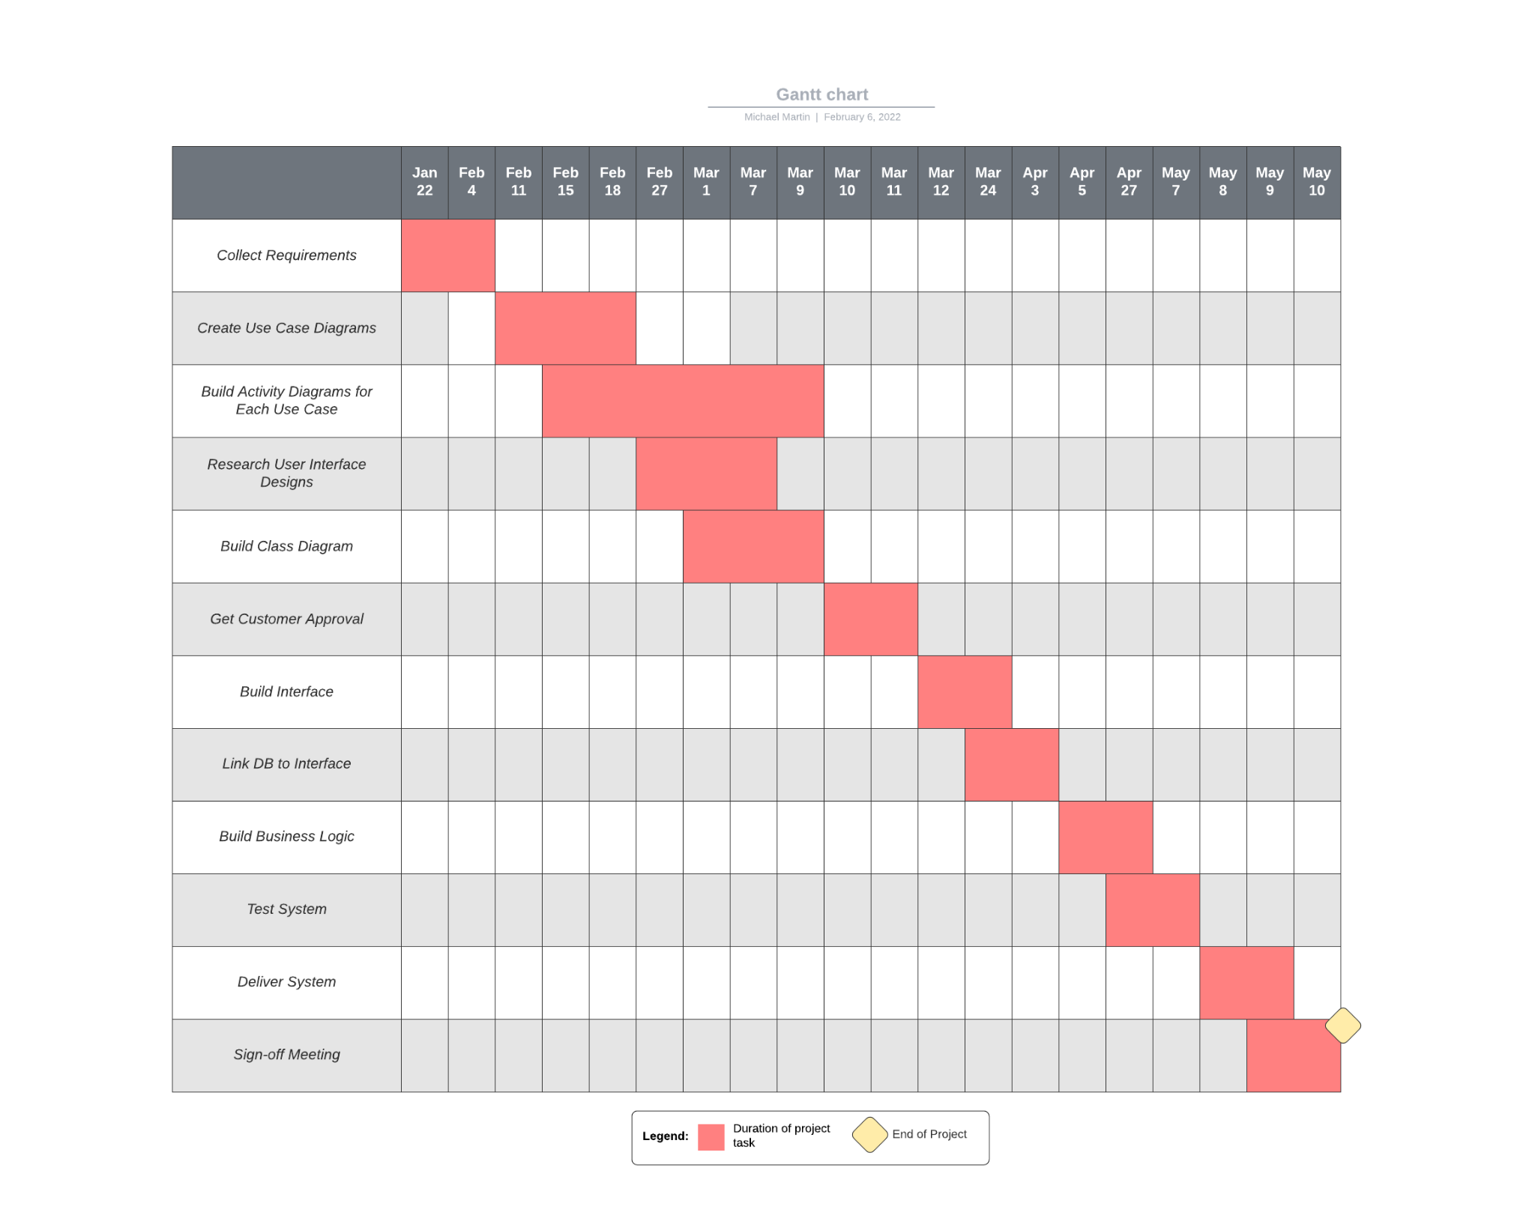

### Gantt Chart

*Please include a screenshot of the GANTT chart that you created with Lucidchart. Be sure to check that it meets the plan described by the characters in the interview.*